Mr. Casey’s Social Studies Class
2nd Quarter Newsletter
Hi everyone! During the 2nd Quarter we will be finishing Chapter 2 on Mesopotamia. The test on Chapter 2 will be on Thursday, December 9th. This is the Quarter where we begin studying Ancient Egypt. I really believe the students will enjoy learning about things like the pyramids, mummification, etc.
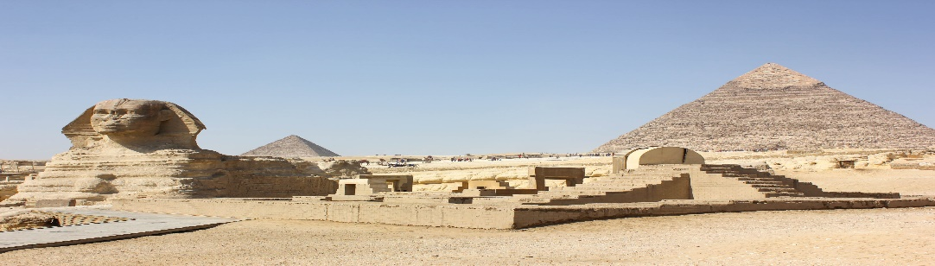

There are also important events we will be discussing in History, such as the anniversary of the Pearl Harbor attack (December 7th) and Martin Luther King Day in January.
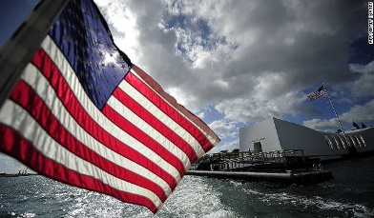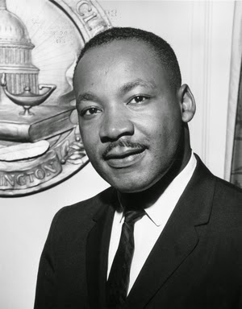
This Photo by Unknown Author is licensed under CC BY-SA

Parents and students are reminded that during the 2nd Quarter the weekly Bell Ringer must be handed in and is graded.

Let’s continue to have a great year!

Mr. Casey

